Employee Name Fields
  - Replace the single Full Name field with two separate mandatory fields:
    - First Name (mandatory)
    - Middle Name
    - Last Name (Mandatory)
  - The system should automatically display the employee's full name by combining the First Name and Last Name fields.

Employment & Shift Management – Required Changes

Payroll Company Integration
- In the Employee Master > Employment section, the Payroll Company dropdown should display the complete company name instead of abbreviated names.
- Payroll Company records must be automatically fetched and synchronized from the CRM Company Master.
- Users should only be able to select active companies available in the CRM Company Master.

Working Days Per Week Configuration

Replace the current Work Week field (5-Day Week / 6-Day Week) with a new Working Days Per Week dropdown.

The dropdown should allow selection from 1 to 7 working days per week.

This setting should be managed from the Shift Management Master.

The selected working days should automatically determine the employee's weekly off days.

The same setting must be used across Attendance, Leave, Holiday, and Payroll modules.

Attendance, absences, leave calculations, payable days, and payroll calculations should automatically follow the selected working days configuration.

Different shifts can have different working day settings, and employees should follow the configuration of their assigned shift.

If the working days setting is changed, it should apply only from the effective date and should not affect past attendance, leave, or payroll records.

CRM Login (ESS Self-Service) Integration
- The CRM Login (ESS Self-Service Access) field should be linked to the employee's existing CRM user account.
- If an employee has a CRM account, the system should display the linked User Name, Email ID, or Login ID instead of showing "Not Linked".
- Administrators should be able to Link, Unlink, or Change the CRM account directly from the Employee Master.
- One employee should be linked to only one CRM user account.
- Any changes made to the CRM account (such as email or username updates) should automatically reflect in the Employee Master.
- Once linked, employees should be able to log in to the Employee Self-Service (ESS) Portal using their CRM login credentials.
- If a CRM account is deactivated or deleted, the ESS access should also be restricted automatically.

- 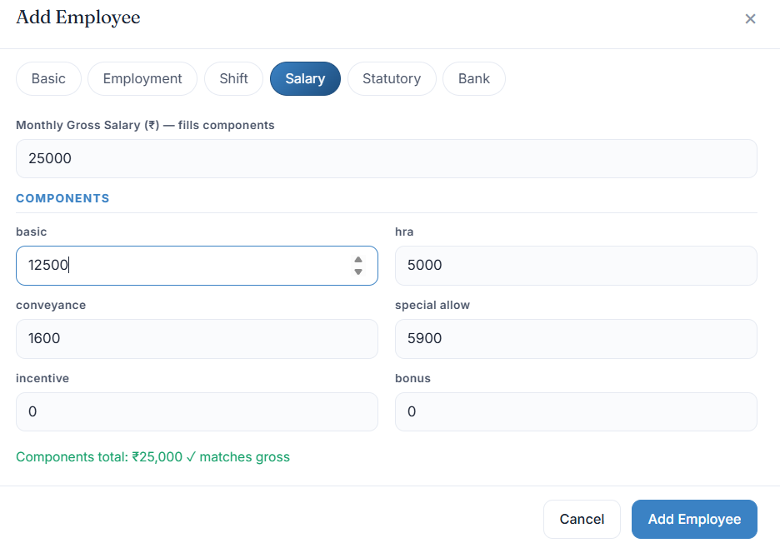

Salary Currency & Country-Specific Deductions
• Add a Currency field in the Salary section to support employees who are paid in different currencies (e.g., INR, CAD, USD, etc.).
• The selected currency should be displayed consistently across Employee Master, Payroll Processing, Salary Verification, Payslips, and Payroll Reports.
• Each employee should have only one active salary currency at a time.
• Salary amounts, earnings, deductions, and net pay should always be shown in the employee's selected currency.

• If the employee's currency is changed, the new currency should apply only from the effective date and should not affect previous payroll records or payslips.

India (INR)
Apply statutory deductions as per Indian payroll regulations:
- Provident Fund (PF)
- ESIC
- Professional Tax (PT) (
- Labour Welfare Fund (LWF)
- TDS (if applicable)

Canada (CAD)
Instead, provide separate configurable deduction fields for:
- CPP (Canada Pension Plan)
- EI (Employment Insurance)
- Income Tax
- Other Deductions
Based on the employee's selected payroll country and currency, the system should automatically display the relevant deduction fields and calculate deductions accordingly. Payroll Administrators should be able to enable, disable, add, edit, or remove deduction types as required.

The calculation formula, percentage, slab, limits, employer contribution, employee contribution, and deduction rules for each deduction type should be fully configurable and editable by authorized users. The system should allow new deduction formulas and rules to be added in the future without requiring system changes or development.

Any changes to deduction formulas or rules should apply only from the effective date and should not affect previously processed payroll records
.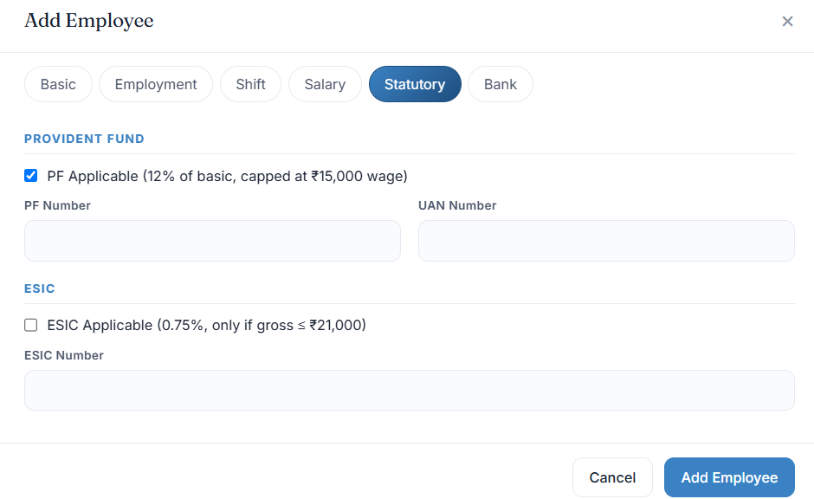

Statutory Information – Required Changes

1. PF & ESIC Applicability

F & ESIC Information
- Add the following fields in the Statutory Information section:
  - Existing PF Account? (Yes/No)
  - Existing ESIC Account? (Yes/No)
- If Existing PF Account = Yes, then PF Number and UAN Number fields should be mandatory.
- If Existing PF Account = No, then PF Number and UAN Number fields should not be mandatory and can be left blank.
- If Existing ESIC Account = Yes, then the ESIC Number field should be mandatory.
- If Existing ESIC Account = No, then the ESIC Number field should not be mandatory and can be left blank.
- Employees who do not have an existing PF or ESIC account may be enrolled later as per company policy. Once enrolled, the relevant PF Number, UAN Number, or ESIC Number should be updated in the employee record.
- PF and ESIC details should be available for payroll processing, statutory reporting, and employee records.

2. Professional Tax (PT)
- Add a Professional Tax (PT) field in the Statutory Information section.
- Default PT deduction should be set to ₹200 per month for applicable employees, this can change anytime.
- The PT amount should be included in payroll calculations and reflected in salary slips and payroll reports.
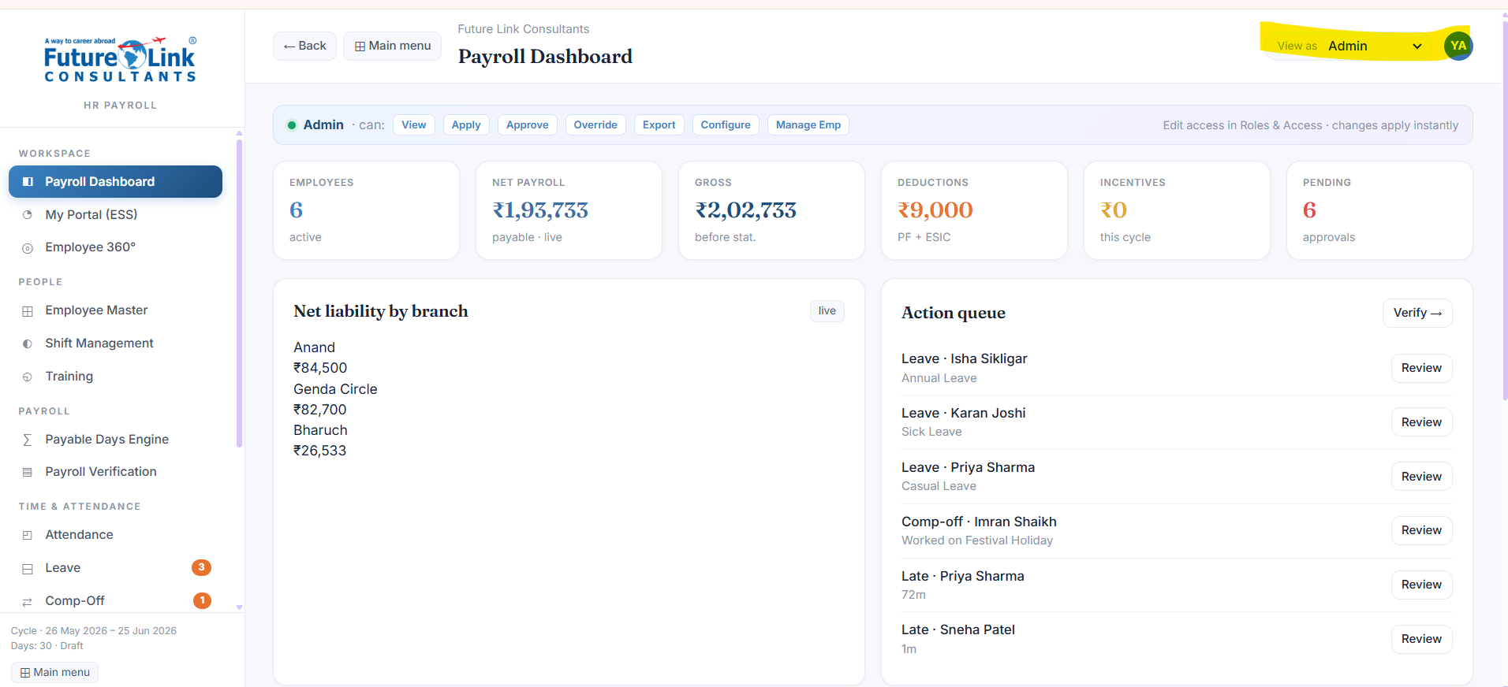

Role-Based Access Control (RBAC) & CRM Integration

1. Restrict Access Based on User Roles
- Currently, all users can view and access the entire HR Payroll System, including modules and role management options.
- This should be restricted through a Role-Based Access Control (RBAC) system.
- Users must only be able to view and access modules, records, and actions that are permitted for their assigned role.
- Users should not be able to view, modify, or switch roles unless they have the required permissions.

2. Centralized Role Management Through CRM
- User roles and permissions for the HR Payroll System should be managed exclusively through the CRM.
- No separate role management system should exist within the HR Payroll module.
- Every employee should inherit their access rights directly from their assigned CRM role.
This needs to be done and merged with the existing user role & access right section once, all the changes have been done, implemented and confirmed by us, then also this will be final step, for the centralized role management.

3. Standard User Roles
The system should support the following default roles:

Employee
Access only to:
- ESS (Employee Self-Service) Portal
- My Profile – editable – but admin can unable or disable it and lock it.
- My Attendance ( Accessible as automated)
- My Leaves - ( Accessible as automated)
- My Holidays - ( Accessible as automated)
- My Training - ( Accessible as automated)
- My Documents - ( Accessible as automated)
- My Payslips - ( Accessible as automated)
- My Salary Information (View Only)

Reporting Manager
In addition to Employee access:
- Team Attendance
- Team Leave Approvals
- Team Training Progress
- Employee 360 View for Direct Reportees
- Attendance and Leave Approval Requests

HR
Access to:
- Employee Master
- Attendance Management
- Leave Management
- Holiday Management
- Shift Management
- Training Management
- Employee Documents
- Employee 360 View
- Reports
HR should not have access to system configuration, role management, or super-admin functions unless specifically granted.

Admin
Access to:
- All HR and Payroll modules
- Payroll Processing
- Payroll Verification
- Payroll Reports
- Payroll Settings
- Employee Transfers
- Employee Exit Management

Super Admin
• The Super Admin role should have unrestricted access to the entire system without any permission limitations.
• Super Admin users should be able to view, create, edit, delete, approve, and manage all records across all modules.
• The Super Admin role should have full access to:
- All CRM Modules
- All HR Modules
- All Payroll Modules
- User Management
- Role & Permission Management
- System Configuration
- Payroll Lock/Unlock Functions
- Audit Logs
- Global Settings
- Reports & Dashboards
- Master Data Management
• Super Admin users should be able to access data across all branches, departments, teams, and entities within the system.

• No module, feature, report, or setting should be restricted for the Super Admin role.

Module & Action Level Permissions
- The system should allow permissions to be configured separately for each module and each action.
- Administrators should be able to grant or restrict the following permissions for every module:
  - View
  - Create
  - Edit
  - Delete
  - Approve
  - Reject
  - Export
- For Payroll modules, additional permissions should be available:
  - Process Payroll
  - Approve Payroll
  - Lock Payroll
  - Unlock Payroll
- Permissions should be assigned based on user roles and should be fully configurable by authorized administrators.
- Users should only be able to access and perform actions that have been assigned to their role.
- The same role may have different permissions in different modules as required by the organization.

5. Security Requirements
- Users must not be able to access unauthorized pages through direct URLs or menu manipulation.
- All permissions must be validated at both the user interface and backend/API levels.
- Every permission change must be recorded in the audit log with:
  - Changed By
  - Date & Time
  - Old Role
  - New Role
  - Remarks
The HR Payroll System must strictly follow CRM-defined roles and permissions to ensure centralized user management, security, and controlled access across all modules.

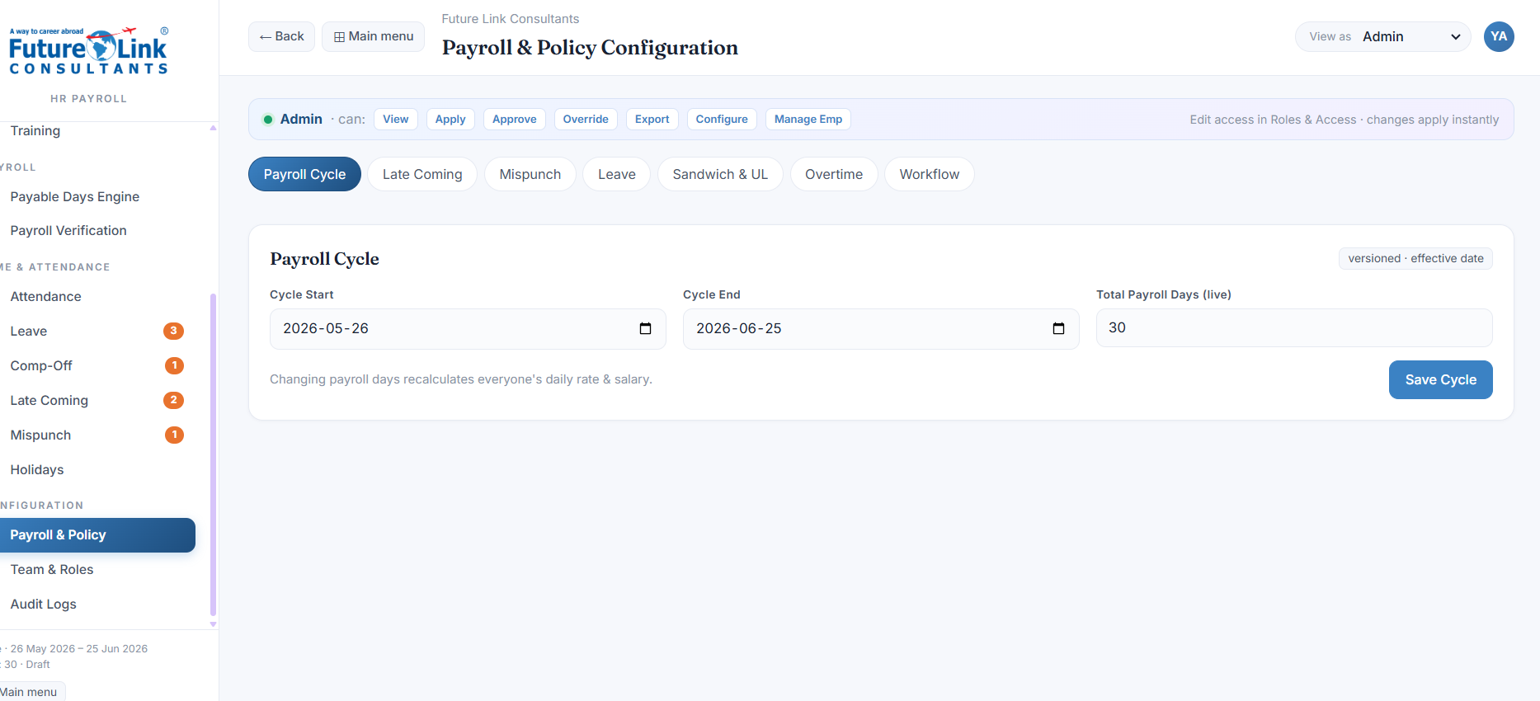

Employee Profile Enhancements

Payroll Calculation
• Salary calculations should automatically consider approved holidays and weekly offs assigned to the employee's shift.
• Holidays and weekly offs should be treated as paid days and should not result in salary deductions, unless specifically marked for deduction by HR or when a weekly off fall under the company's sandwich leave policy.
• If holidays differ between shifts, only the holidays assigned to the employee's current shift should be considered during payroll calculation.

Additional Employee Information
Add the following fields to the Employee Profile:
- Marital Status
- Blood Group
- Nationality

Emergency Contact Details
Allow multiple emergency contacts to be added, maximum 2 contact can be added.
Fields:
- Contact Name
- Contact Number
- Contact Relation

Employment Information
Add the following fields under Employment Details:
- Reporting Manager (from the existing users list in the drop down)
- Probation Start Date
- Probation End Date

Exit Information
Add the following fields for employee exit management:
- Exit Date
- Exit Reason
- Resignation / Discontinuation Email – option to upload
- Rehire Eligible (Yes / No)

Salary Information Enhancements
Add the following fields in the Salary Tab:
- Professional Tax (PT)
- TDS
- Labour Welfare Fund (LWF)
- Other Deductions
- Net Salary

Salary Revision History
Maintain complete salary revision records.
Fields:
- Effective Date
- Old Salary
- New Salary
- Revised By
- Revision Remarks
Salary revision history must remain permanently available for audit and payroll reference.

5. Bank Information (Current Bank Tab)

Add
- Branch Name
- Account Type
- Security Cheque Upload -
- Passbook Upload
- Verification Status
- Verification Date
- Verified By - need to mention name

Employee Document Management

Document Upload
For every required document, provide an Upload Document option.
When the user clicks Upload:
- Select File
- Add Remarks (Optional)
After upload, the document status should automatically change to:
- Uploaded
- Verified
- Rejected
Verification should be performed by HR/Admin.

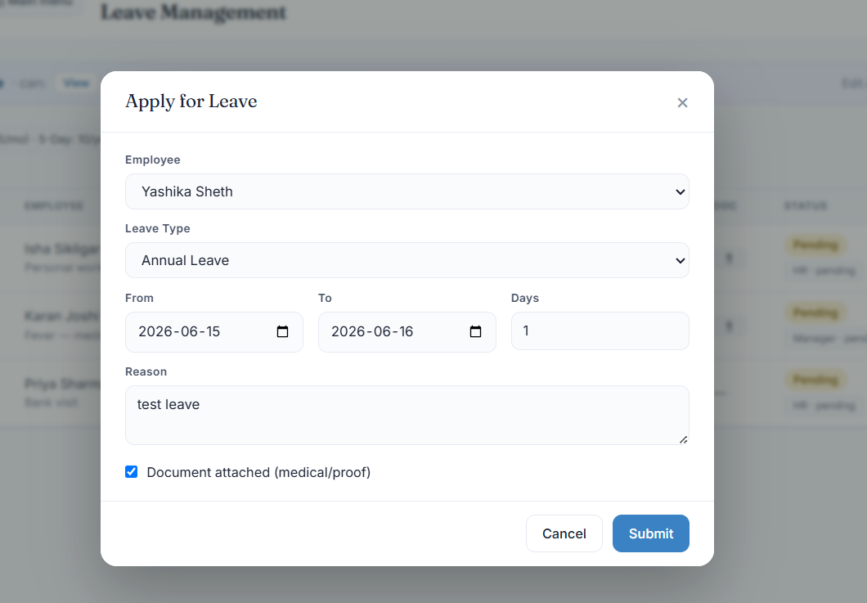

Leave Management Enhancements

Leave Application
While applying for leave, employees should have the option to upload supporting documents or images.
Supported file types should include images and PDF documents.

Leave Cancellation
Employees should be able to cancel a leave request if it is no longer required.
Rules:
- Leave requests can only be cancelled before the leave start date.
- Cancelled leave should automatically restore the leave balance.
- Cancellation history should be recorded with date, time, and employee details.
- If the leave has already been approved, the cancellation request should follow the approval workflow defined by the company.

Leave History & Date Filters
Add date range filters in Leave Management for both employees and administrators.
Users should be able to view leave records for:
- Custom Date Range
This should help users easily track leave usage for any selected period.

Leave Balance Summary
Display a leave summary section showing:
- Total Leave Balance
- Paid Leave Available
- Paid Leave Taken
- Unpaid Leave Taken
- Leave Pending Approval
- Leave Rejected
- Leave Approved
- Leave Remaining
This summary should be visible to employees before applying for leave and should update automatically after every leave transaction.

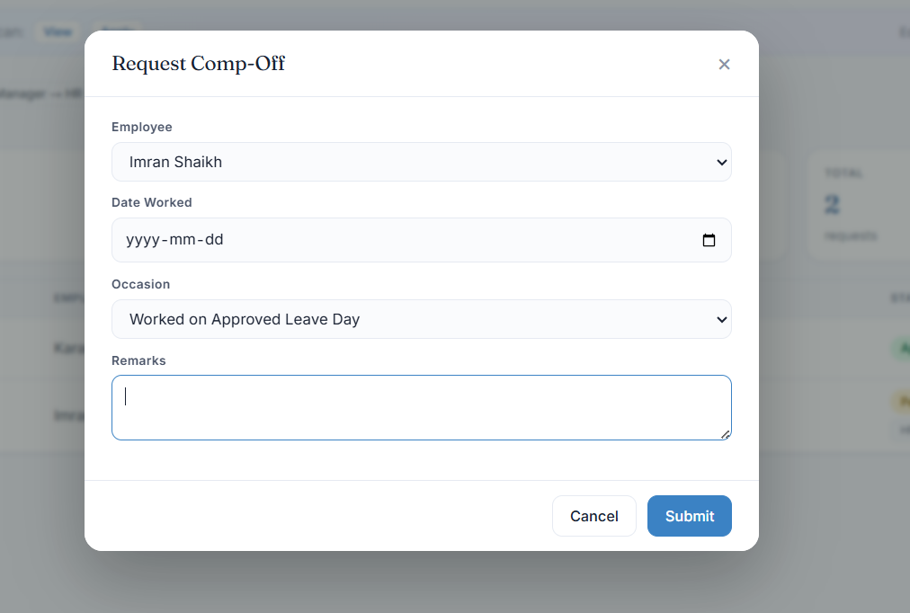

Supporting Documents & Leave Duration
While applying for comp off leave, employees should have the option to upload supporting documents or images. On which date he wants the leave, from when to when.
- Specify the amount of additional work completed, selecting one of the following:
  - Full Day
  - Half Day
  - Partial Day (Few Hours)
For Partial Day, employees must enter the Start Time and End Time of the additional work performed, and the system should automatically calculate the total hours worked.
The selected leave duration must be considered during attendance processing, leave balance calculations, and payroll calculations, if approved by the hr then only.

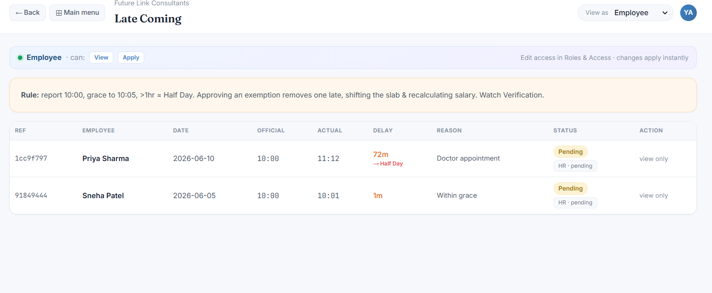

Late Coming Exemption Request
Request Form Fields:
- Late Coming Date
- Actual Login Time (auto-fetched from attendance records)
- Shift Start Time (auto-fetched from assigned shift)
- Total Delay Duration (auto-calculated)
- Reason (mandatory)
- Supporting Document/Image Upload (optional)
Rules:
- The exemption request must be submitted on the same day as the late arrival.
- Employees should not be allowed to submit exemption requests for previous dates.
- The request should be routed to HR for approval.
- The system should maintain a complete approval and rejection history, including approver details, action date/time, and remarks.
- Upon approval, the applicable late coming deduction should be waived and reflected in attendance and payroll calculations.

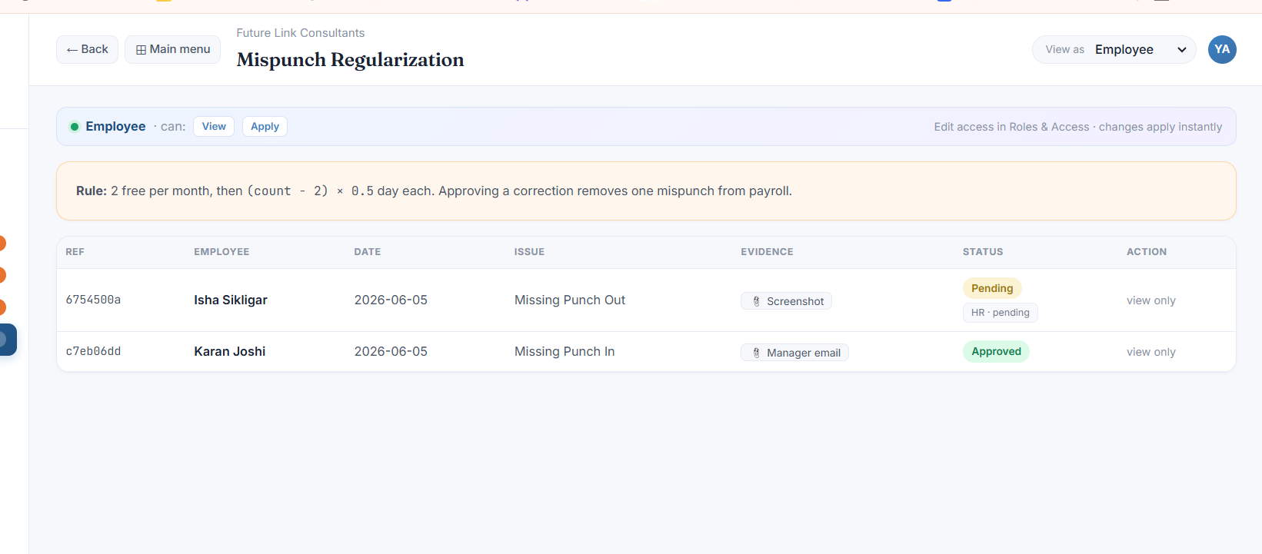

Mispunch Exemption Request
Employees should have the option to submit a request for correction or exemption in case of a mispunch.

Fields
- Attendance Date
- Mispunch Type
- Reason
- Supporting Document / Image Upload

Rules
- The request must be submitted on the same day as the mispunch.
- Requests for previous dates should not be allowed.
- The request should be sent to the HR for approval.
- Employees should be able to track the status of their request.

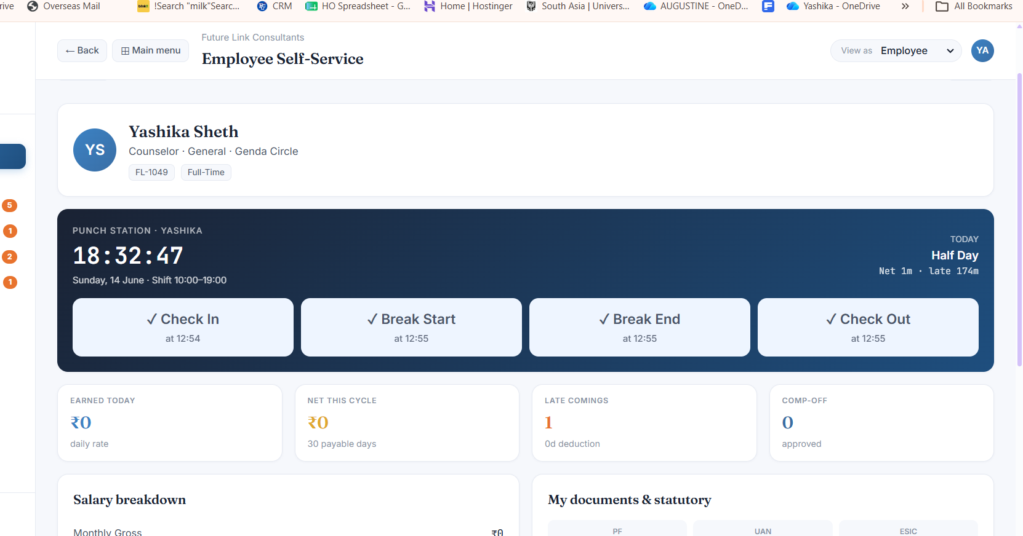

Attendance Status Visibility
- The employee's current attendance status should be clearly visible on the dashboard.
- When an employee checks in, the status should show Available.
- When an employee starts a break, the status should change to Unavailable / On Break.
- When the employee returns from break, the status should change back to Available.
- After check-out, the status should show Checked Out.
- It should be immediately clear whether the employee is currently checked in, on break, or checked out.
Leave Balance Visibility
Display the employee's leave summary on the dashboard.
- • Total Leave Balance
- • Leave Earned This Month
- • Leave Taken This Month
- • Leave Approved
- • Leave Pending Approval
- • Leave Rejected

•

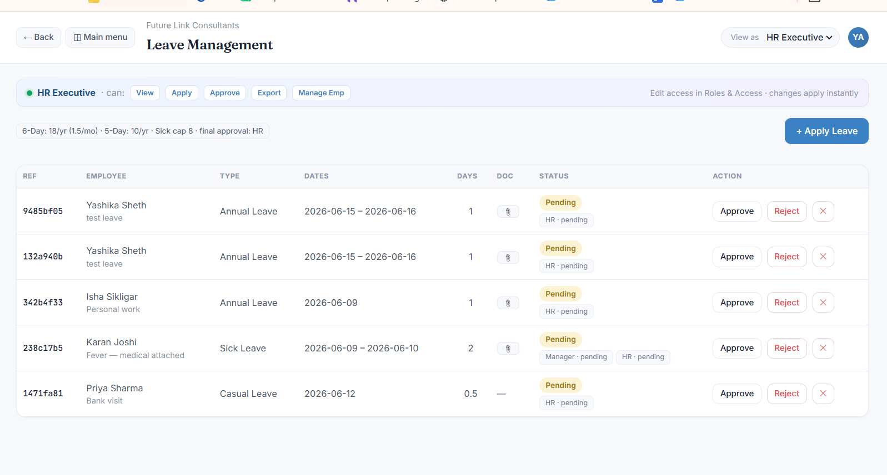

When rejecting a leave request, the approver must provide a rejection reason.

The rejection reason should be visible to the employee.

When approving a leave request, the approver should be able to choose:

Fully Approved

Partially Approved

For partial approval, the approver should specify the approved leave duration.

The approver should also be able to add approval remarks/reason.

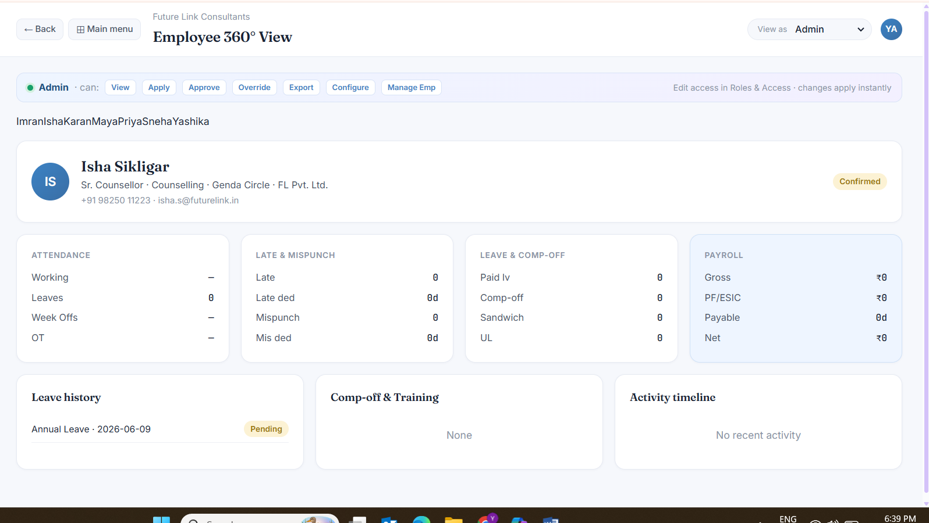

Employee 360 View
- In Employee 360 View, Admin, HR, and the employee's Reporting Manager should be able to view a complete employee summary from a single screen.
- The summary should include employee profile, attendance, leave, payroll, documents, training, performance, reporting manager, employment details, and activity history.

Shift Management Master

Weekly Off Configuration
- While creating a shift, allow selection of one or multiple weekly offs.
Example:
- Sunday
- Monday
- Tuesday
- Wednesday
- Thursday
- Friday
- Saturday
These weekly offs should automatically be considered during attendance processing, leave calculations, and payroll calculations.

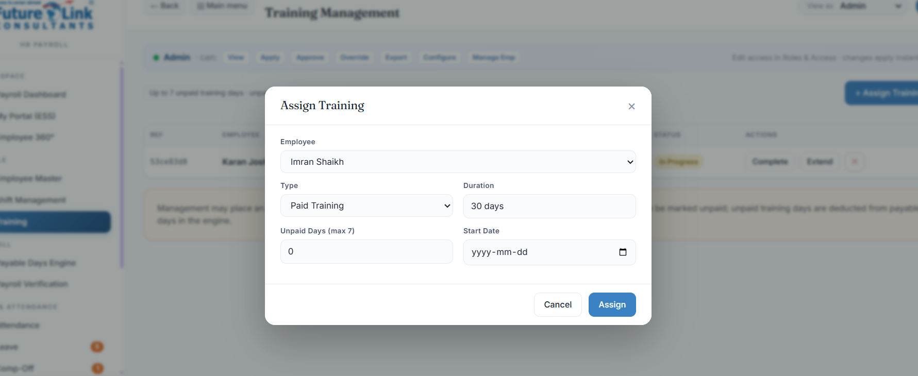

Training Master – Assign Training
- While assigning training, provide filters and assignment options based on:
  - Branch – from the existing crm branch list
  - Department - from the existing crm department list
  - Designation - from the existing crm designation list
  - Reporting Manager (from the existing employee list from the CRM)
This will allow training to be assigned to a specific employee, team, department, branch, or the entire organizatio

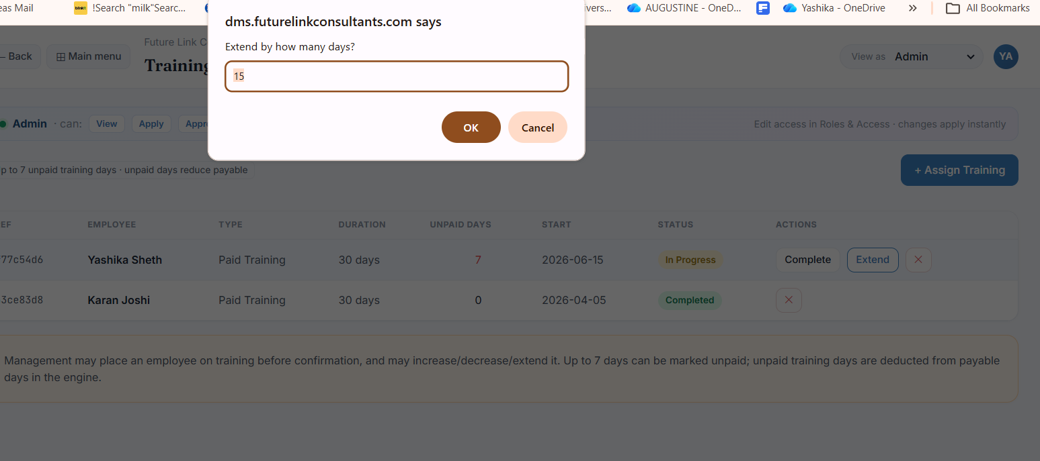

Training Extension & Completion Workflow
- When a training is marked as Extended, a calendar/date selection field should appear to allow the user to select the new completion date.
- The user must provide a mandatory reason for extending the training.
Fields:
- Extended Until Date
- Extension Reason

- If the training is completed before the extended completion date, the user should be able to mark the training as Completed.
- While marking it as completed, the user should provide a reason or remarks explaining why the training was completed earlier than the extended date.
Fields:
- Completion Date
- Completion Remarks / Reason
The system should maintain a history of all extensions and early completions, including the date, reason, and user who performed the action.

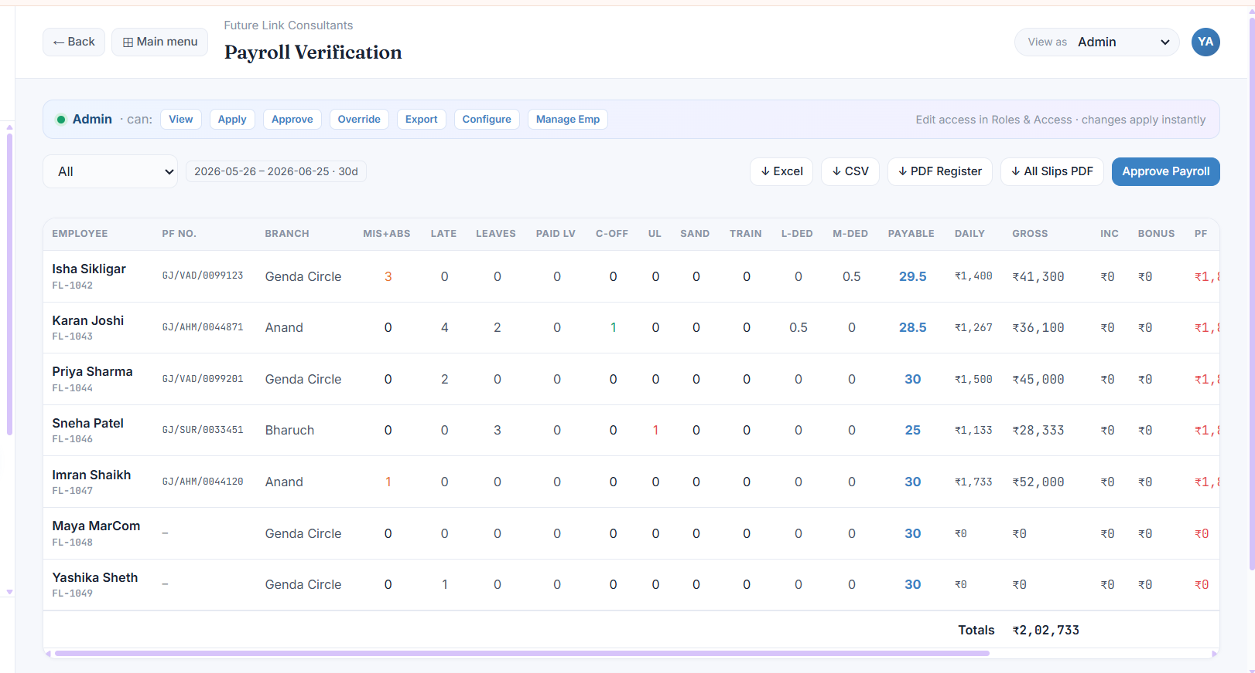

Payroll verification fields as not same. After branch following heads should be there in okace if MIS + ABS, late, leave, paid lv, c-off, ul, train, L-ded, m-ded.
MIS PUNCH | No of Late Comings | No. of Leaves Taken | Actual Working Days | Total Paid Leaves | Total W/Off | Payable Days | Late Deduction Days | Unauthorized Leave (UL) | Sandwich Leave  Days | Mispunch Deduction Days

And hide – these fields.
Daily | Gross | Inc | Bonus | PF | ESIC | Net Salary

And we should be able to filter this for specific employee, entire branch, department, or particular company or all the employee, and multiple selection option should also be there

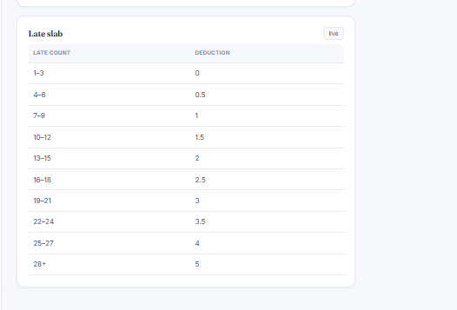

We should be able to edit this late coming deduction slab

Monthly Payroll Cycle Management (Mandatory)
The system should automatically create payroll cycles based on the Payroll Master settings (Payroll Start Date and Payroll End Date).
Example:
- Cycle #1: 26-May-2026 to 25-Jun-2026
- Cycle #2: 26-Jun-2026 to 25-Jul-2026
- Cycle #3: 26-Jul-2026 to 25-Aug-2026
Each payroll cycle should be saved as a separate and permanent record. Once a payroll cycle has been processed and approved, it must not be overwritten, deleted, or modified by future changes.
Any updates made to salary structures, payroll rules, deduction rules, leave policies, shift settings, or other payroll configurations should apply only to newly created payroll cycles and must not affect previously processed cycles.
This ensures that historical payroll records always remain accurate and reflect the exact data and rules that were in effect when the payroll was processed.

Payroll Cycle Generation
The system should automatically generate payroll cycles based on the Payroll Master settings and should provide options to:
- Generate Next Payroll Cycle
- Generate Future Payroll Cycles
- View Active Payroll Cycle
- View Upcoming Payroll Cycles
- View Previously Processed Payroll Cycles
Each payroll cycle should be created using the following configured dates:
- Payroll Start Date
- Payroll End Date
- Salary Processing Date
- Salary Credit Date
The system should clearly display the status of each cycle (Upcoming, Active, Processing, Completed, or Closed) and maintain all generated payroll cycles as separate records for future reference and audit purposes.

7. Payroll Lifecycle
Each payroll cycle should follow a defined workflow to ensure proper review, approval, and audit tracking:
Draft → Processed → Approved → Locked → Paid
The system should record the complete history of every stage, including:
- Processed By and Processed Date & Time
- Approved By and Approved Date & Time
- Locked By and Locked Date & Time
- Paid By and Paid Date & Time
The current status of the payroll cycle should be clearly visible at all times, and the system should maintain a complete audit trail of all actions performed during the payroll process.

8. Locked Payroll Rules
Once a payroll cycle reaches the Locked or Paid status, it should be treated as a finalized payroll record.
Any changes made after payroll has been locked or paid must not alter the processed payroll, generated payslips, or payroll calculations for that cycle.
Only users with Unlock Payroll permission should be allowed to reopen a locked payroll cycle. All unlock actions must be logged with the user name, date and time, and mandatory remarks for audit purposes.

9. Payroll History
The system should maintain a complete history of all payroll cycles processed within the organization.
Each payroll record should display:
- Payroll Cycle Name and Date Range
- Payroll Status (Draft, Processed, Approved, Locked, Paid)
- Total Employees Included
- Gross Payroll Amount
- Net Payroll Amount
- Processed By
- Processed Date & Time
- Approved By
- Approved Date & Time
Users with appropriate permissions should be able to:
- View Payroll History
- Search and Filter Historical Payroll Records
- Open Historical Payroll Cycles
- Export Historical Payroll Data
- View Historical Payslips
- Download Historical Payslips
- Audit Historical Payroll Records
Historical payroll records must remain permanently available and accessible for reporting, audit, compliance, and employee reference purposes.

10. Historical Snapshot Engine (Mandatory)
For every payroll cycle, the system must automatically create and store a complete read-only snapshot of all data, calculations, and policies used during payroll processing.
The snapshot should be created when payroll is processed or approved and must remain permanently linked to that payroll cycle.
Once created, snapshot data must be immutable (non-editable) and must not be affected by future changes in attendance, salary structures, leave balances, shifts, holidays, or company policies.

Attendance Snapshot
Store the exact attendance data used for payroll calculation:
- Working Days
- Present Days
- Absent Days
- Holidays
- Weekly Offs
- Leave Days
- Late Marks
- Overtime
- Comp-Off
- Unauthorized Leave
- Mispunch Records

Leave Snapshot
Store the exact leave information used during payroll processing:
- Opening Leave Balance
- Leave Earned
- Leave Used
- Leave Deducted
- Closing Leave Balance

Salary Snapshot
Store the exact salary structure applicable at the time of payroll processing:
- Basic Salary
- HRA
- Conveyance
- Special Allowance
- Incentive
- Bonus
- PF
- ESIC
- Professional Tax (PT)
- TDS
- LWF
- Other Deductions
- Net Salary

Policy Snapshot
Store the exact policies and rules that were active when payroll was processed:
- Payroll Rules
- Shift Rules
- Leave Rules
- Overtime Rules
- Late Deduction Rules
- Sandwich Leave Rules
- Holiday Rules

Payroll Snapshot
Store the final payroll calculation results:
- Gross Salary
- Total Earnings
- Total Deductions
- Payable Days
- Net Pay
- Generated Payslip
- Payroll Status
- Payroll Approval Details

Example
For June 2026 Payroll, the system should preserve:
- June Attendance Snapshot
- June Leave Snapshot
- June Salary Snapshot
- June Policy Snapshot
- June Payroll Snapshot
Even if HR later changes:
- Salary Structure
- Shift Assignments
- Attendance Records
- Holiday Calendars
- Leave Policies
- Overtime Rules
- Late Deduction Rules
the June payroll must continue to display and calculate exactly as it was originally processed, approved, and paid.
This ensures complete payroll accuracy, audit compliance, and protection of historical payroll records.

